**Programs on the Basics of Java**

1. Write a program to display “Hello World!!!” Use the command line to run this program.

**Logic:**

Step 1: Start

Step 2: Using command system.out.println print “Hello world”

Step 3: Stop

**Code:**

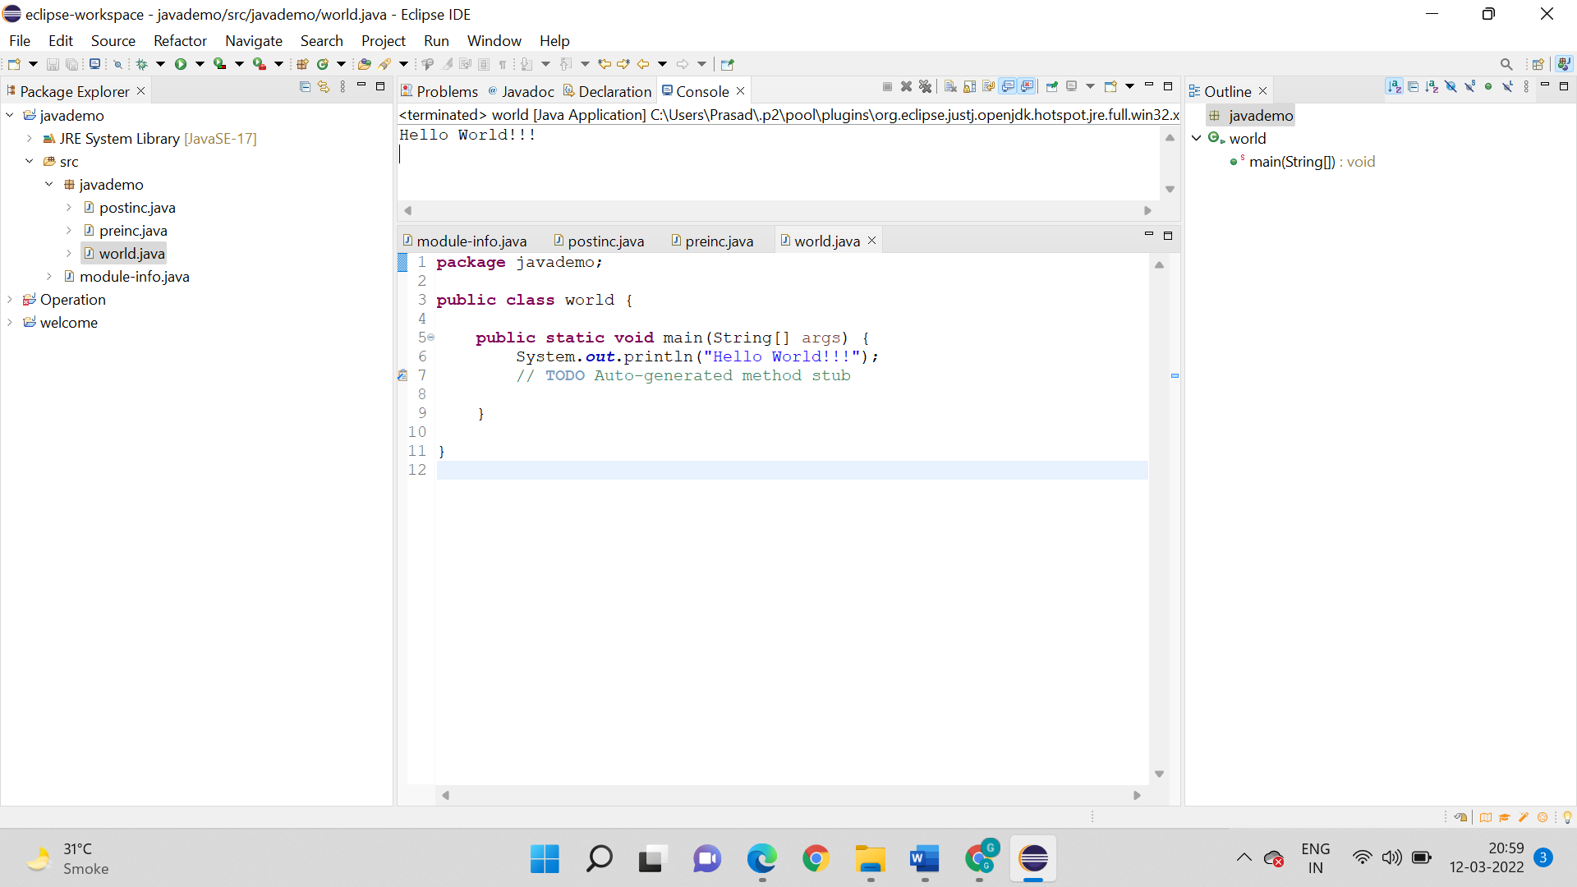

**Output:** Hello World!!!



**2. Write a program to generate a welcoming message for the Programmer.**

**Logic:**

Step 1: Start

Step 2: Using command system.out.println print “Welcome Programmer” as the output

Step 3: Stop

**Code:**

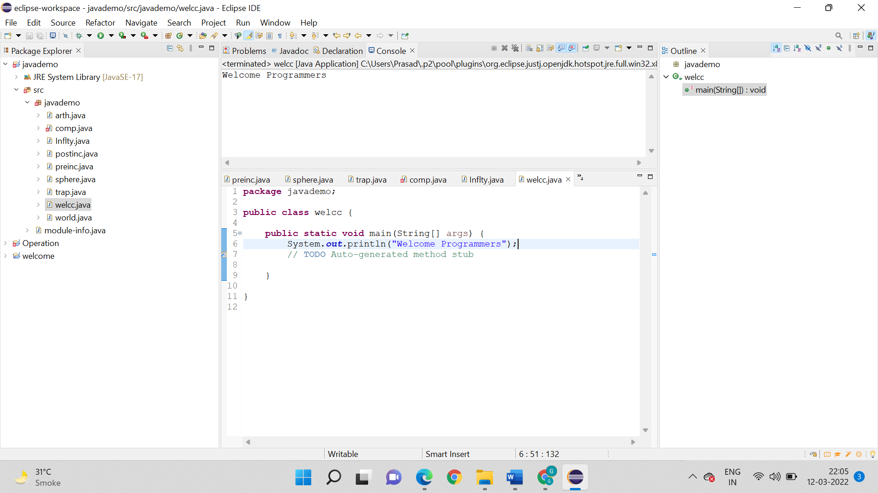

**Output:**

Welcome Programmers



**3. Write a program to demonstrate the use of arithmetic operators.**

**Logic:**

Step 1: Start

Step 2: First we have declared a and b. The “a” and “b” are the 2 integers having values 2 and 5 respectively.

Step 3: Variables are declared for performing addition ,multiplication ,subtraction and division respectively.

Step 4: The respective outcomes for each of them have been printed.

Step 5: Stop

**Code:**

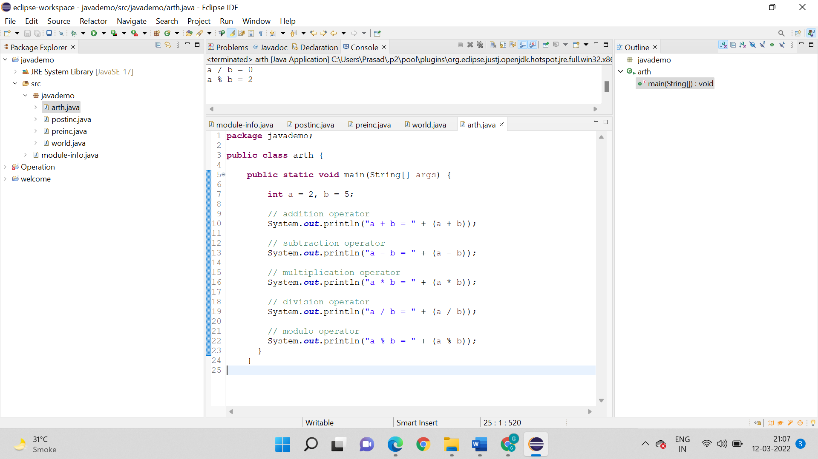

**Output:**

a + b = 7

a - b = -3

a * b = 10

a / b = 0

a % b = 2

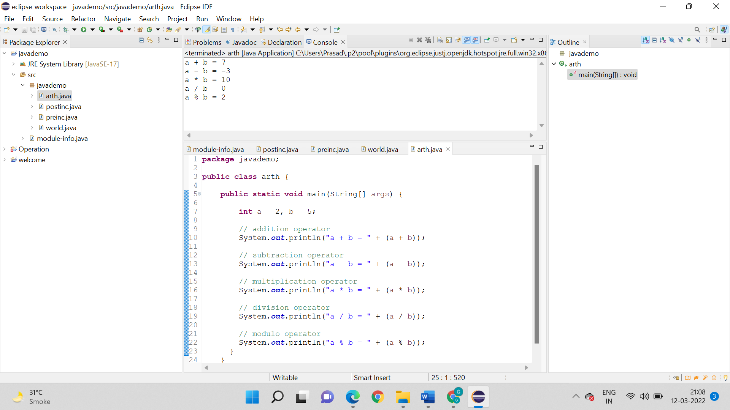

**4. Write a program to demonstrate the use of increment and decrement operators. Use both cases (For example: x++ and ++x)**

For PreIncrement:

**Logic:**

Step 1: Start

Step 2: Here 2 variables have been declared. “x” and “y” are the two variables.

Step 3: “x” is initialized as 15 . The “y” variable is used to display all the results .

Step 4: “x” has been printed in the beginning .

Step 5: Then it has been pre incremented where the value has been again been incremented and the incremented value has been displayed.

Step 6: Stop

**Code:**

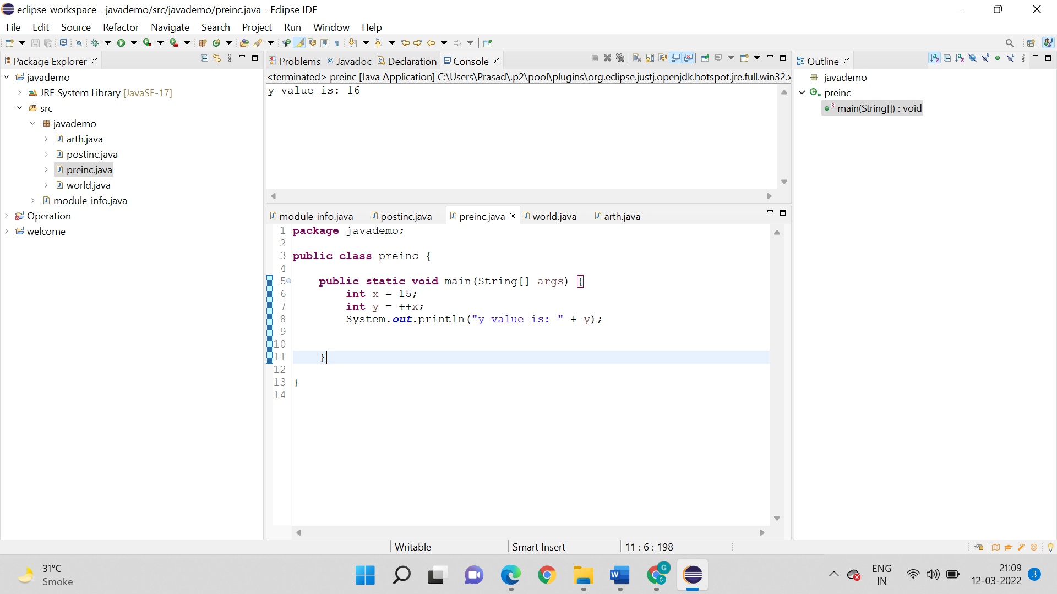

**Output:** 16



**PostIncrement:**

**Logic:**

Step 1: Start

Step 2: Here 2 variables have been declared. “x” and “y” are the two variables.

Step 3: “x” is initialized as 8 . The “y” variable is used to display all the results .

Step 4: “x” has been printed in the beginning .

Step 5: Then it’s post incremented where the output would be same but in memory it has been incremented by 1.

**Code:**

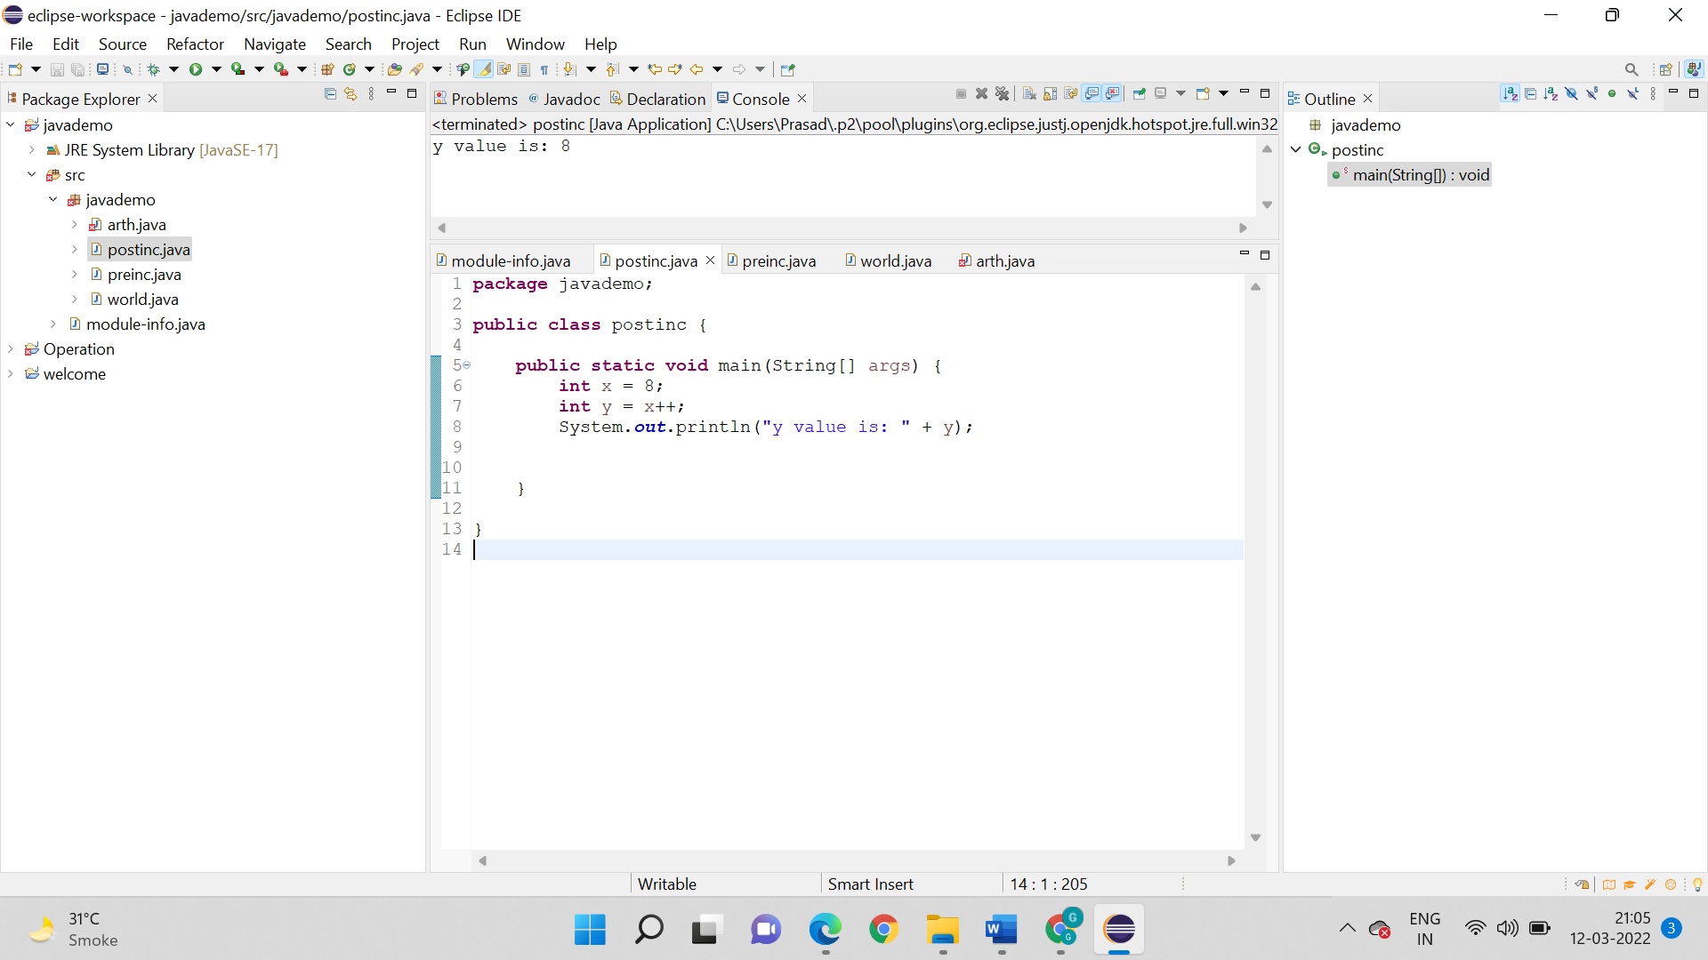

**Output:**

8



**5. Write a program to calculate the area of a sphere (4πr2) with a radius 30 units. Calculate the area of trapezium (height*(base1+base2/2)) with height 15 units and bases 20 units and 25 units respectively. Use appropriate data types.**

**Area of a sphere:**

**Logic:**

Step 1: Start

Step 2: So we have 4 variables been declared as integers .

Step 3: The radius = 30 units, height “height” = 10

Step 4: We know area of a sphere = (4πr2)

Step 5: Than the variables have been outputted .

Step 6: Stop

**Code:**

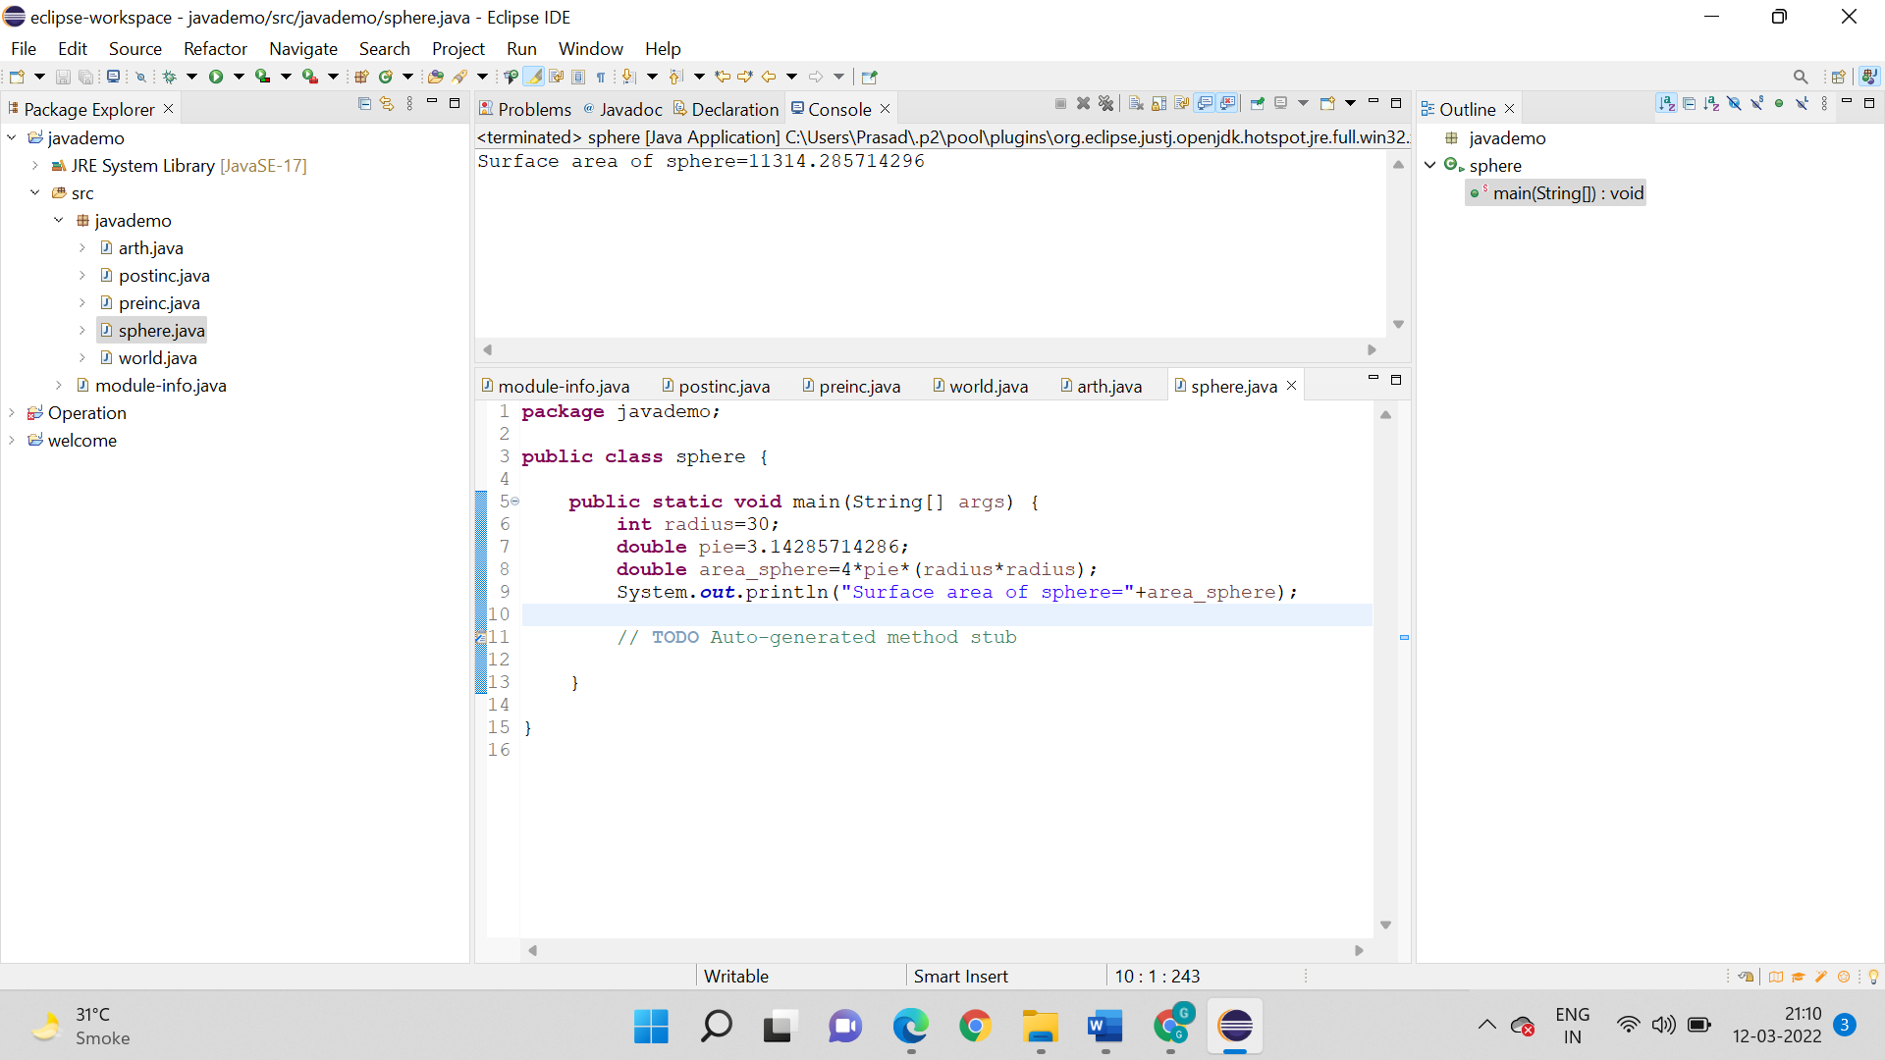

**Output:**

**Surface area of sphere=11314.285714296**



**Area of trapezium:**

**Logic:**

Step 1: Start

Step 2: We have 4 variables been declared as integers .

Step 3: The height “height” = 10 and bases : “double base b1” = 34 and “double base b2” =20.

Step 4: We know area of trapezium (height*(base1+base2/2))

Step 5: Than the variables have been outputted .

Step 6: Stop

Area = 1/2*(sum of parallel sides)*height of the trapezium

**Code:**

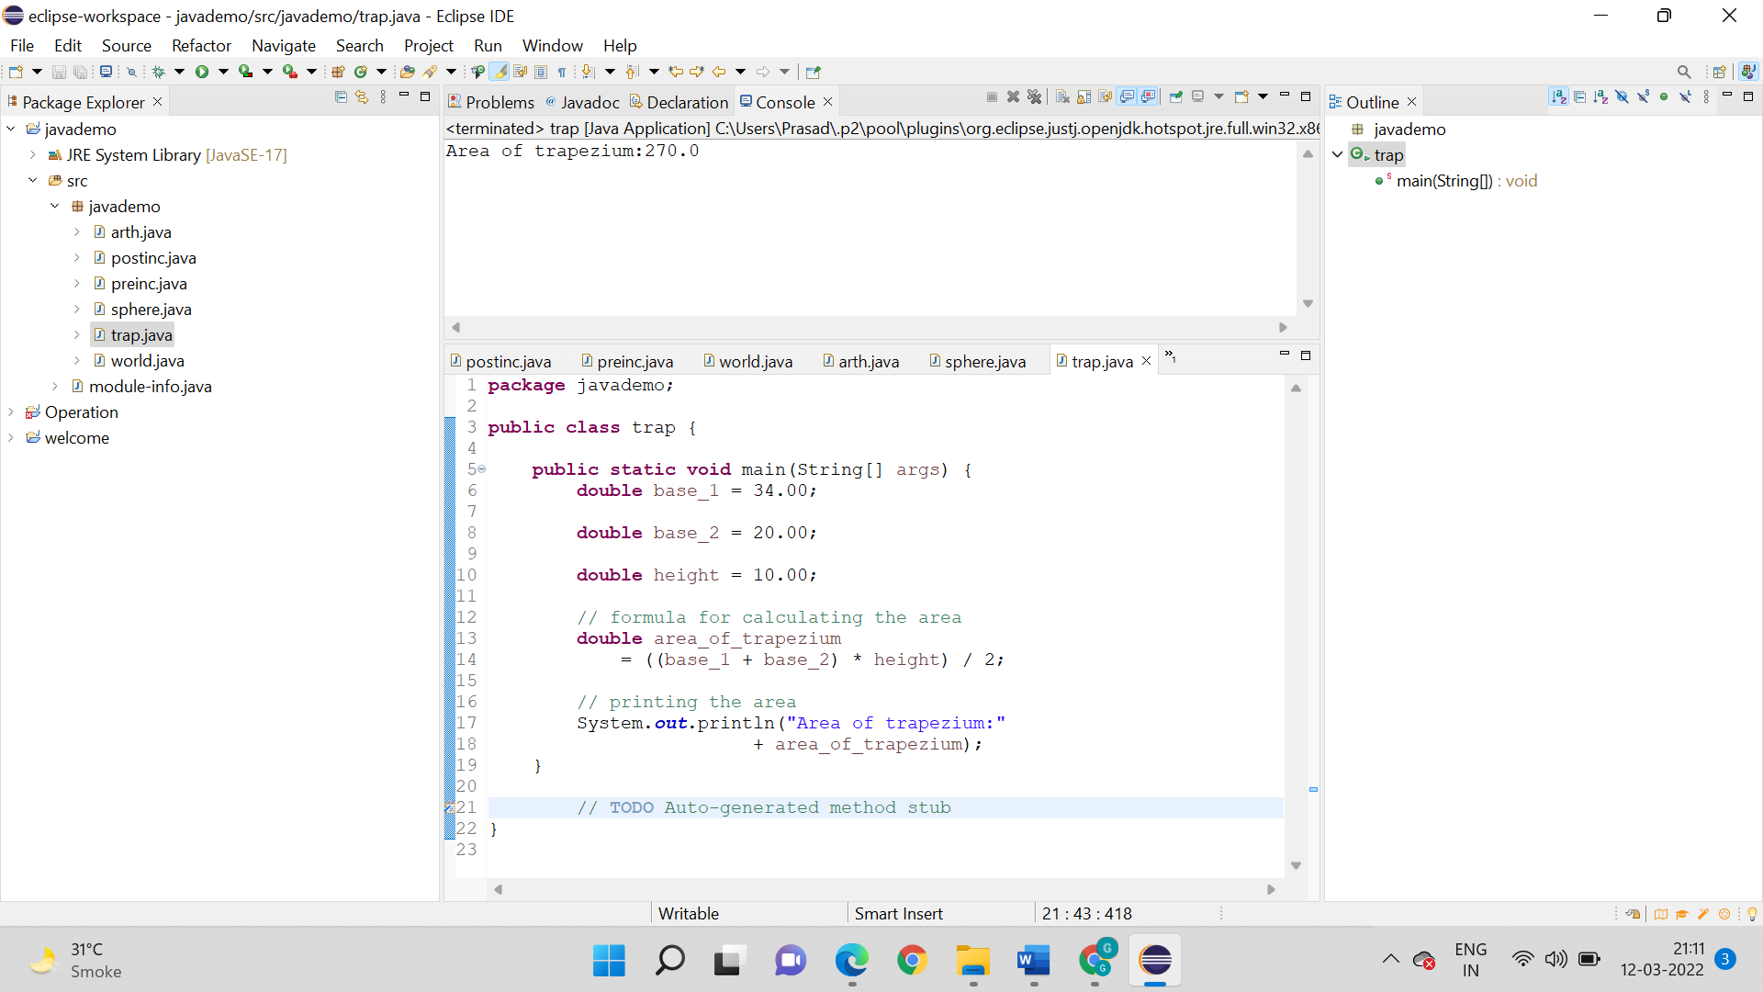

**Output:**

270



**6. Write a program to demonstrate the use of compound assignment operators. Use all the arithmetic operators.**

**Logic:**

Step 1: Start

Step 2: Create a main method ()

Step 3: Variables are x, y and z

Step 4: So, the x , y, z integer datatype are used for performing operations

Step 5: Print statement is used to display the output respectively

Step 6: Stop

**Code:**

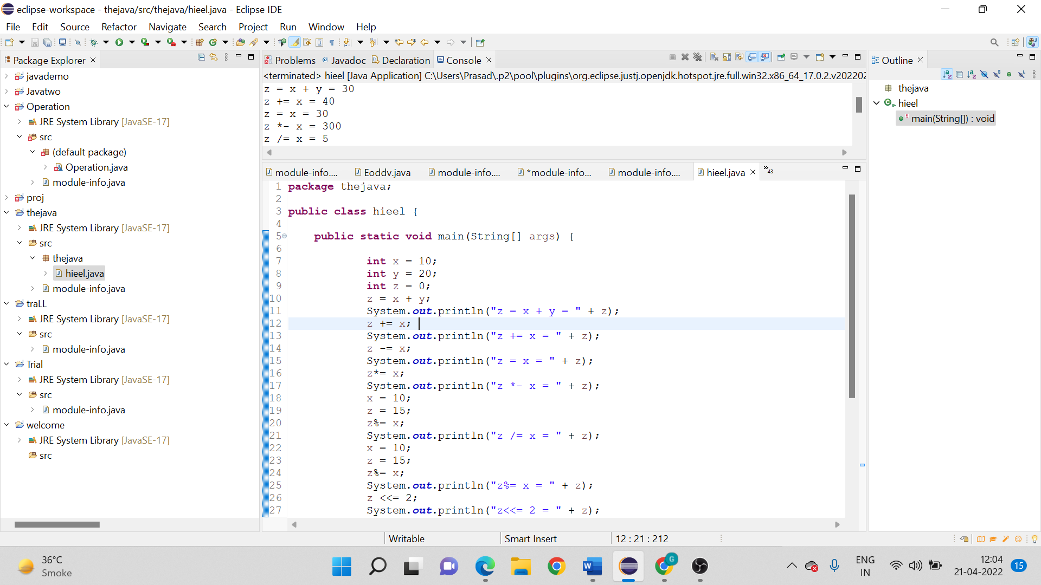

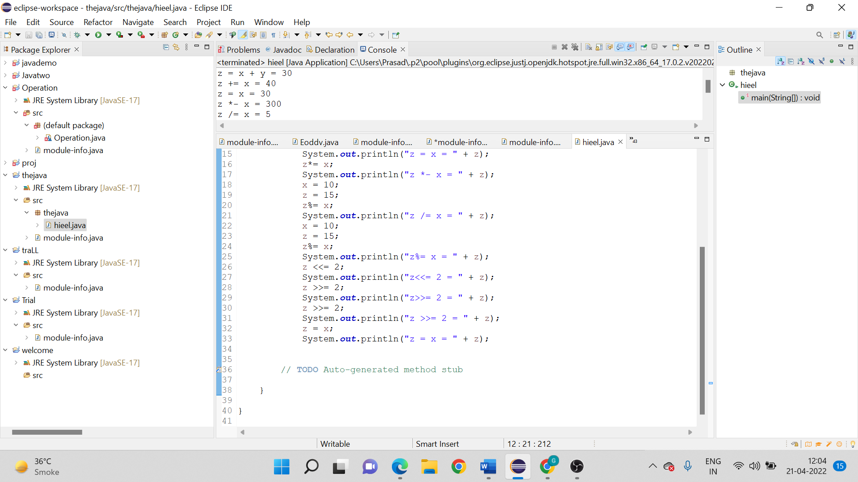

**Output:**

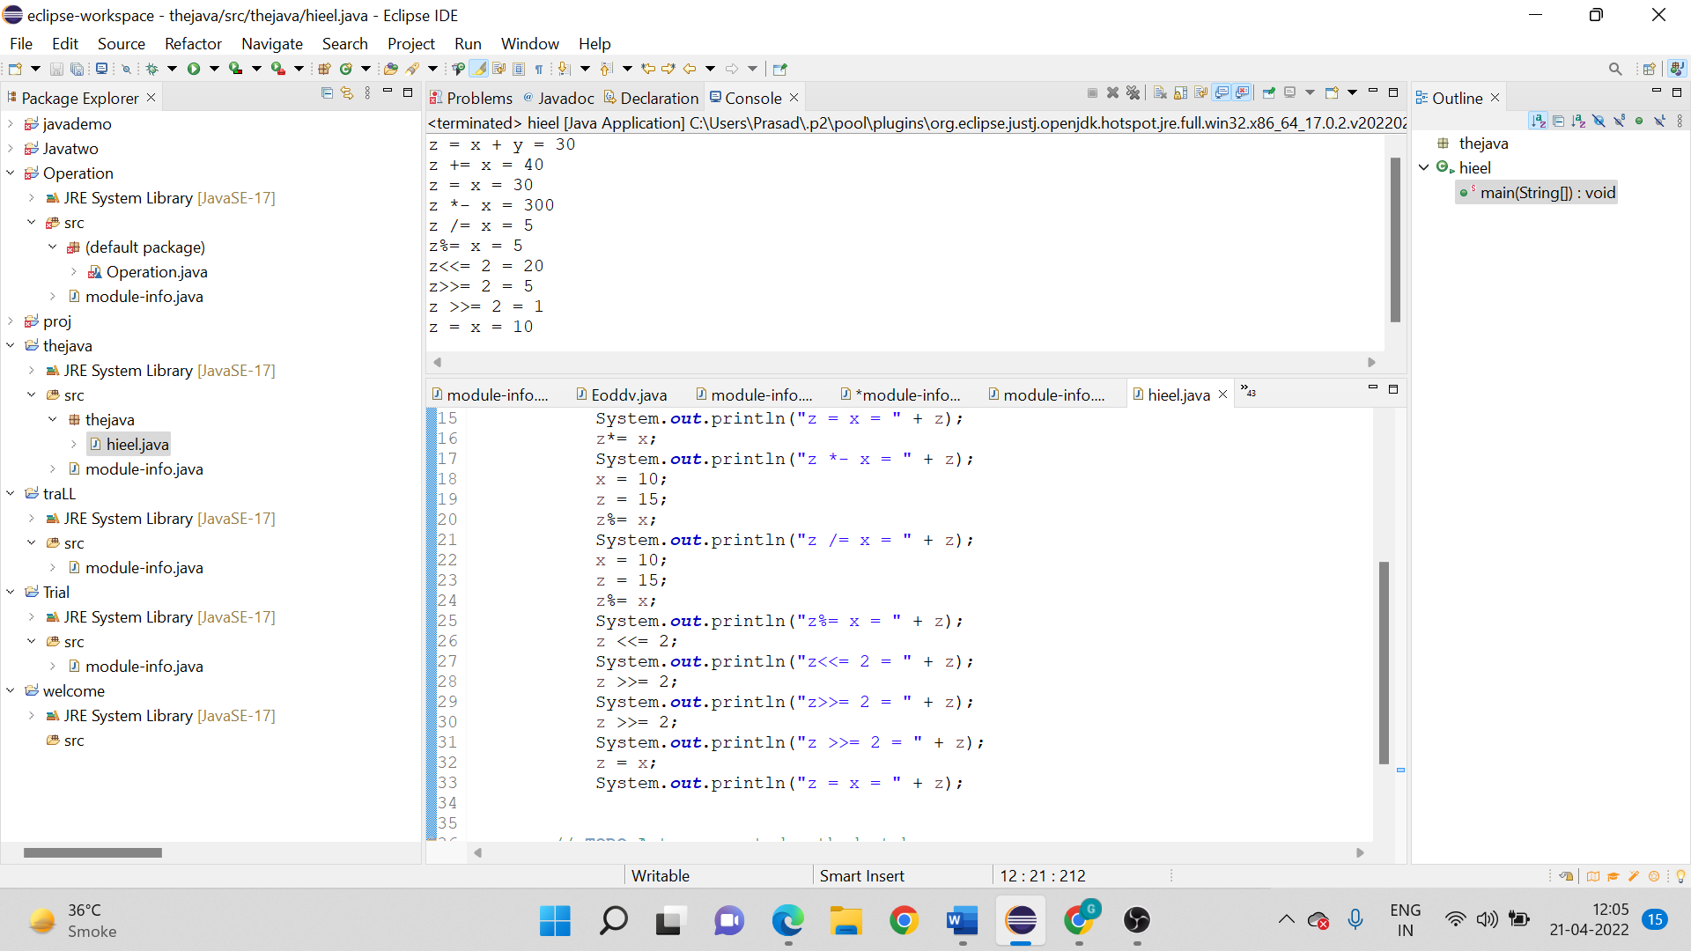

**7. Write a program to demonstrate the conversion of Integer value to a Byte datatype, Floating point value to Integer value and Floating-point value to Byte datatype.**

**Logic:**

Step 1: Start

Step 2: So we declare byte variable “b”.

Step 3: Integer “i” is initialized as 111 .

Step 4: Float “f” has been initialized as 21.

Step 5: Integer is converted to byte and then it gets printed .

Step 6: Similarly Float gets converted to Integer and float to byte .

Step 7: So the outcomes are printed respectively.

Step 8: Stop

**Code:**

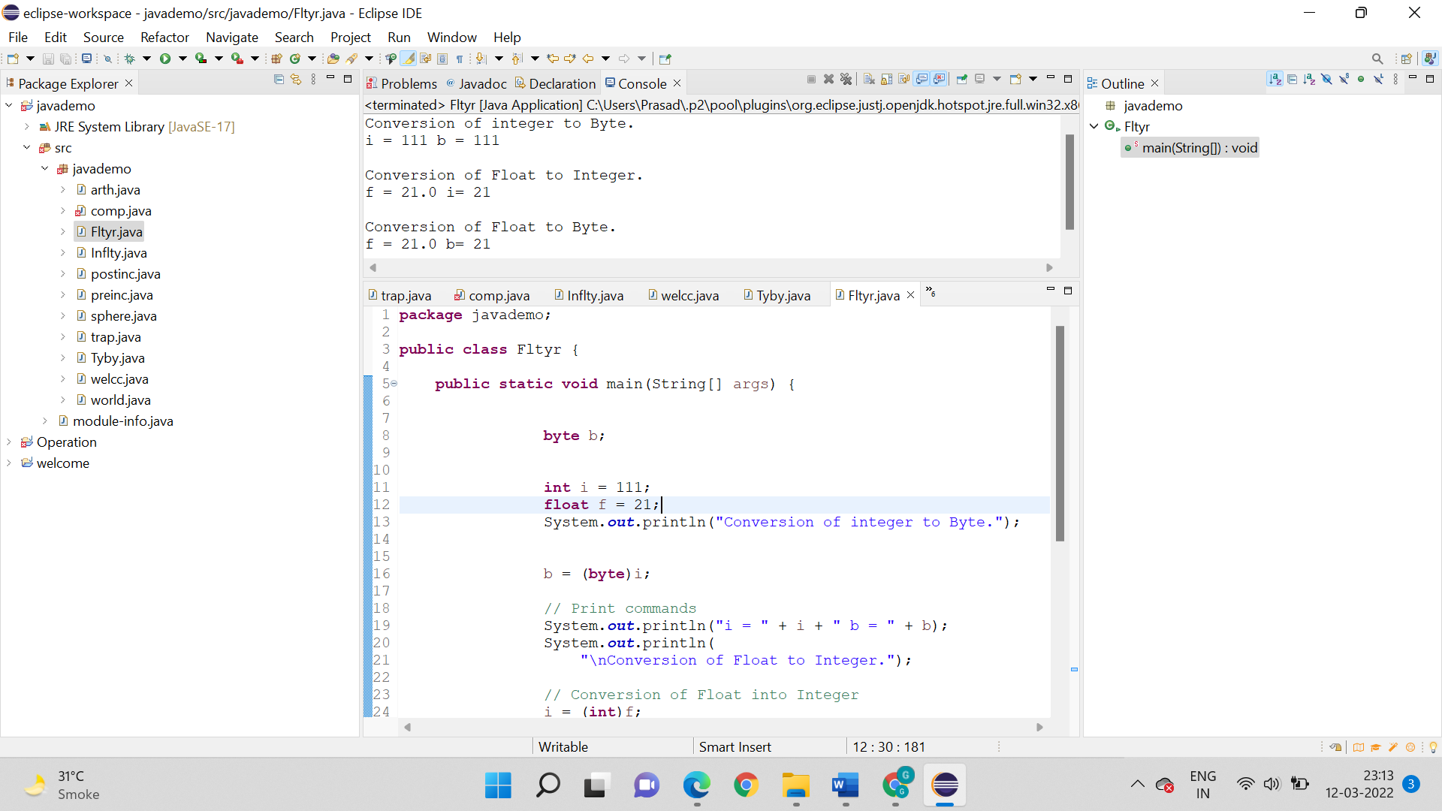

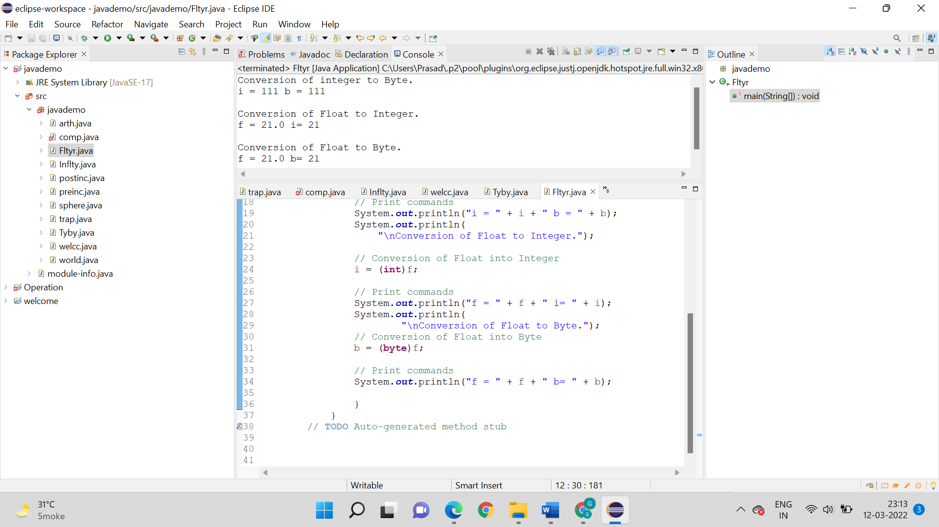**Output:**

